Video 1.Jmeter installation:

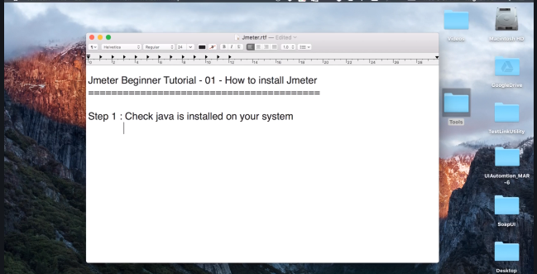

Go to the cmd and run java -version

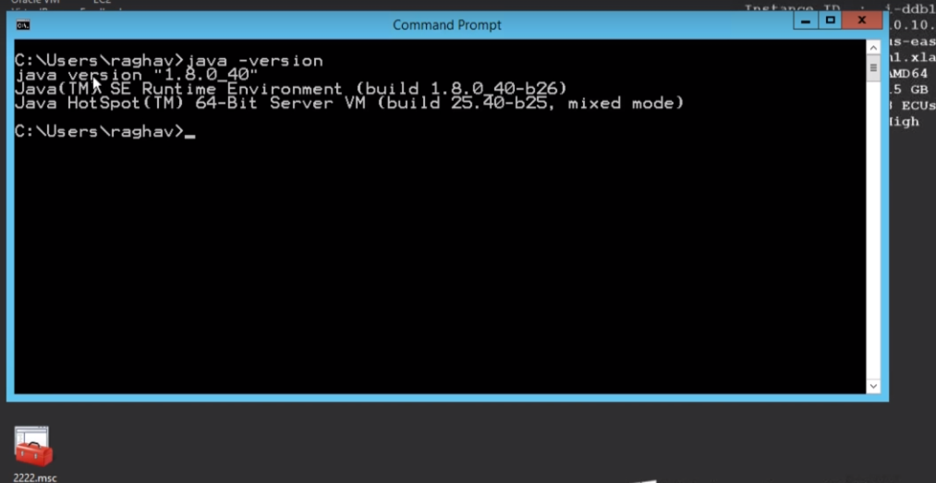

2.Download JMeter:

Go to apache site and download the JMeter zip file.

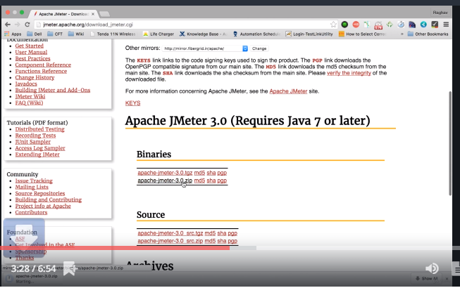

3.Unzip the jmeter.zip folder and keep it in any folder.

4.Start JMeter

In windows-> JMeter-> bin->double click on jmeter.bat the JMeter work bench is opened s below

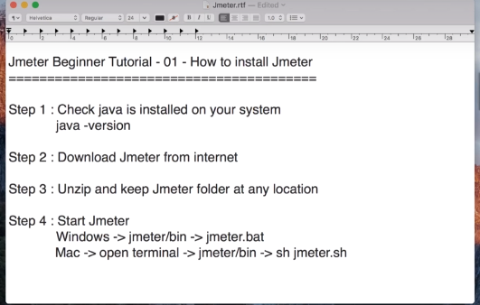

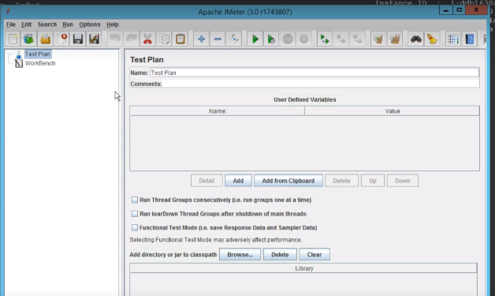



Video 2. How to create first JMeter test.

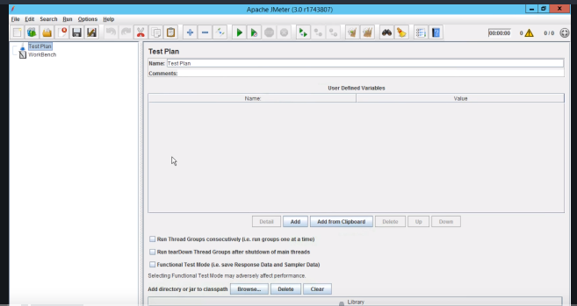

Rename the test plan.

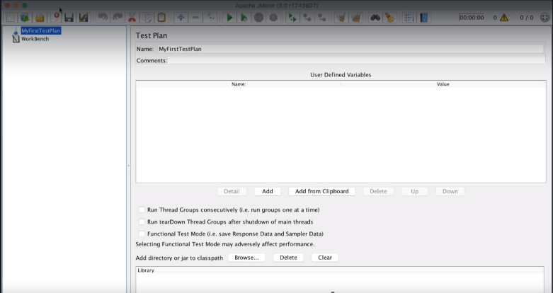

Add thread group.

->The thread group is used to create and run the test.it is the user

Test plan->add->Threads(users)-> Thread Group and rename the thread group.

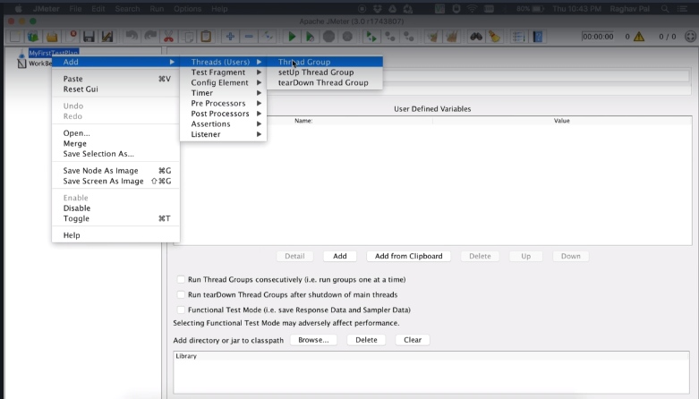

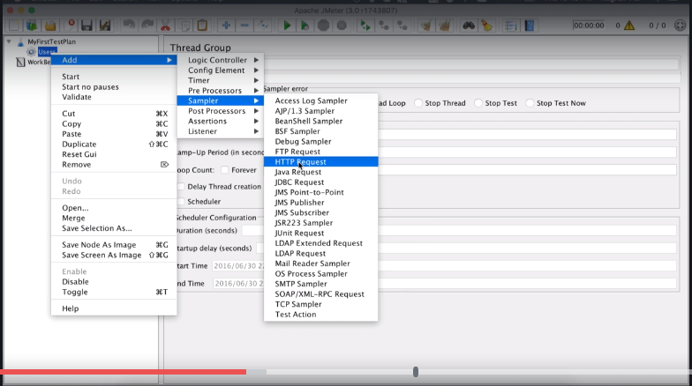

Add the request thread group-> add->sampler-> http request.



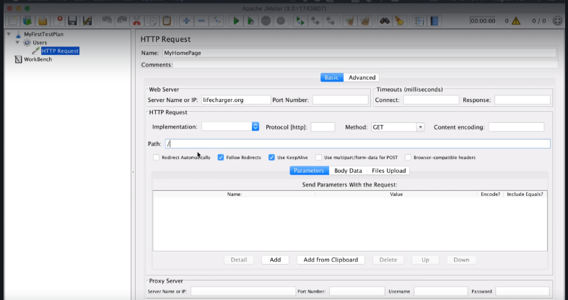

->Here the server name or ip should be url without http or https.

-> in the protocal [http] if the leave blank it is consider as http:

-> in the port number field is there any port number is present in the url then you should provide the port number.

->in the path field enter text as below (ex: /myacc/mbLogin.jsp?noFollow=true)

Add listeners for view the results

Thread group->add->listeners->view results tree and view results in table.

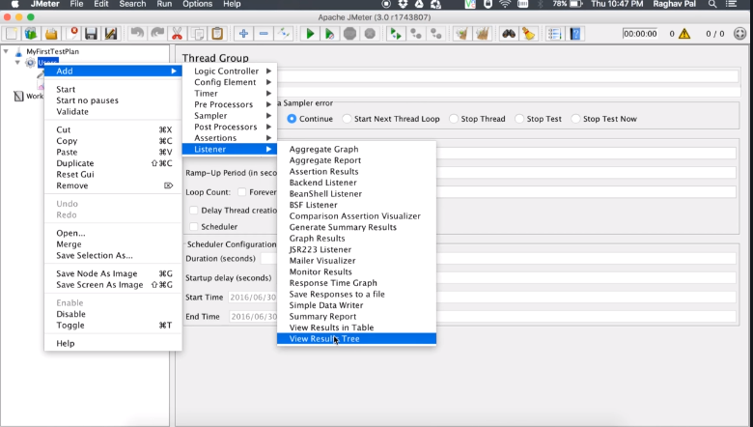

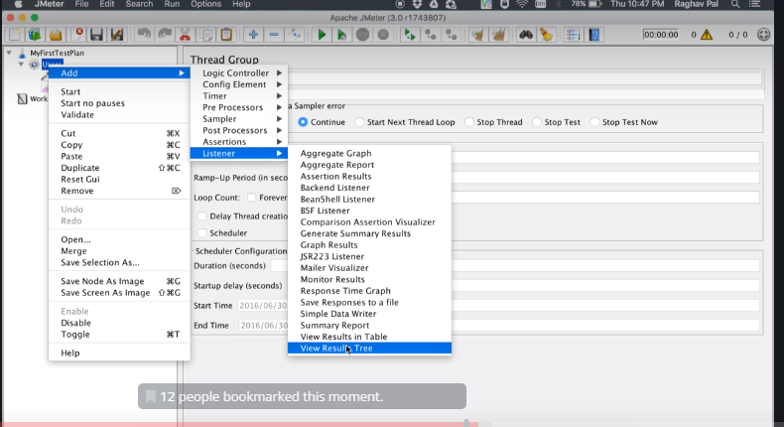

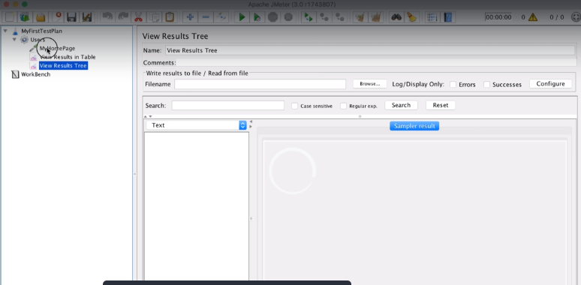

Execute the test.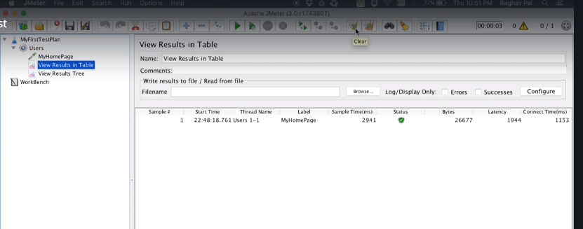

Assertions

Video 3: Assertions

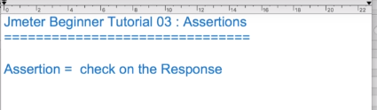

To add assertions Thread group->add->Assertions->Response Assertions

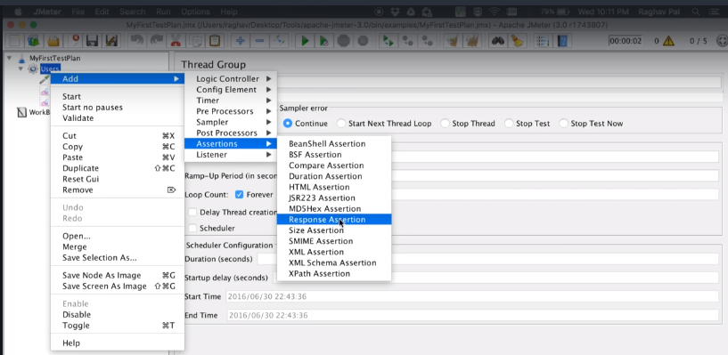

Add the assertion details

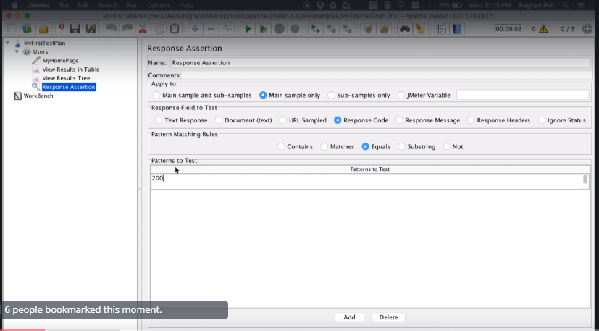

Add the details for the thread group and click on run button.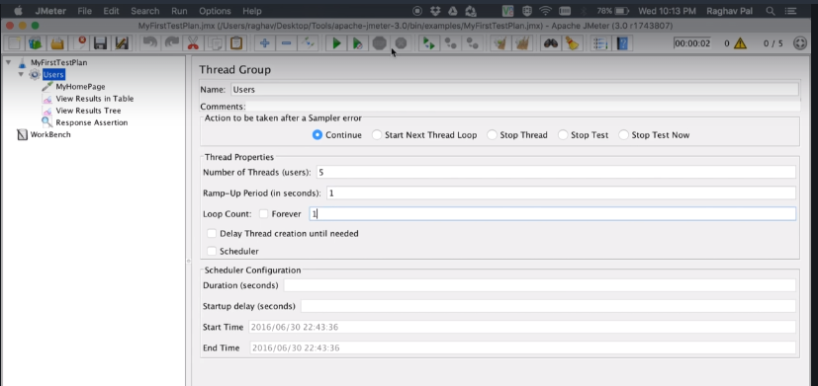

Results is below

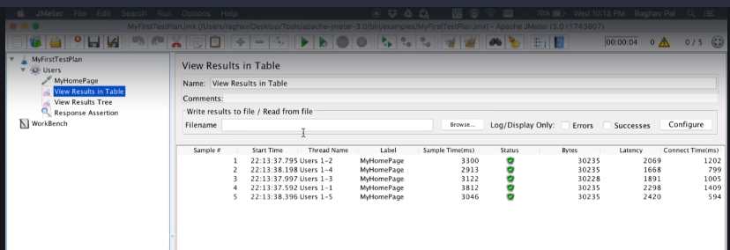

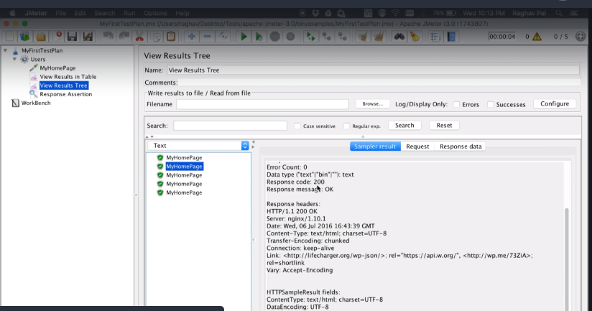

To fail the assertion, change the response from 200 to 201 or something and agin run the test.

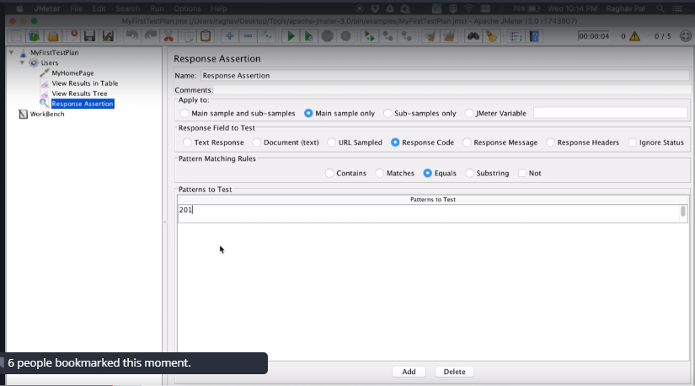

The failed test results is as below

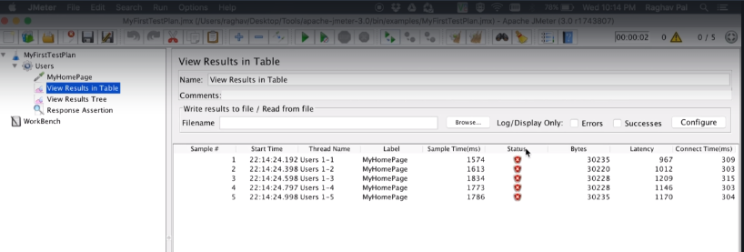

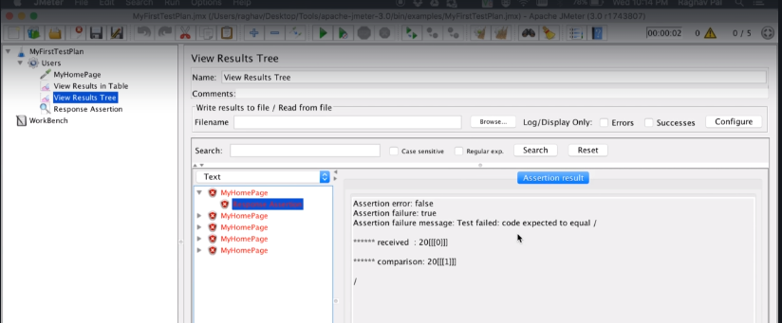

Add assertion results for better view of the assertions results .we can add the assertion results . thread group->add-> Listeners-> Assertion Results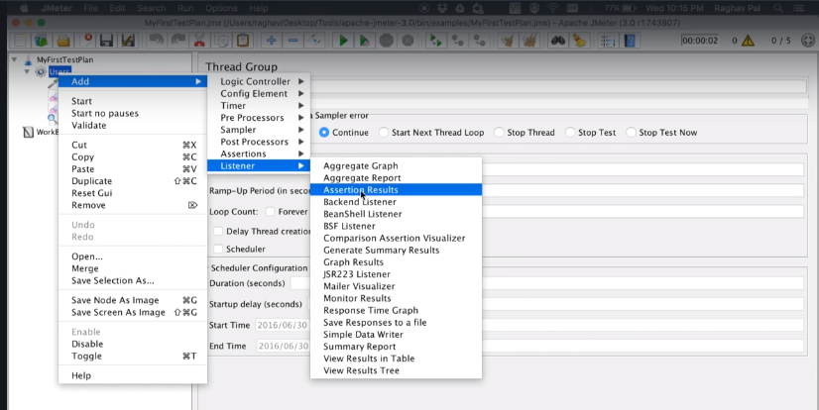

Run test again the assertion results are displaying like as below.

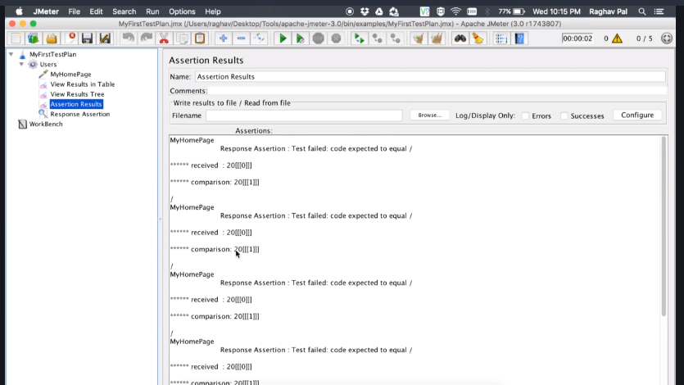

For positive response

Change the response from201 to 200 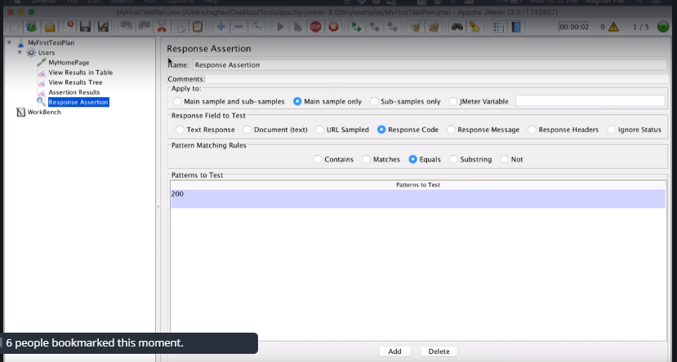

and again, run the test the results as below.

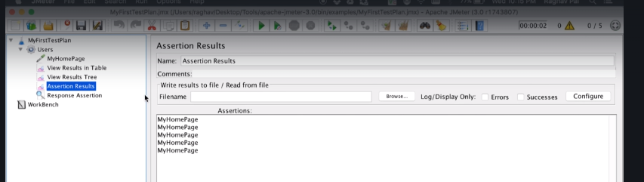

Add duration assertion

Threadgroup-> Add-> Assertions-> Duration Assertion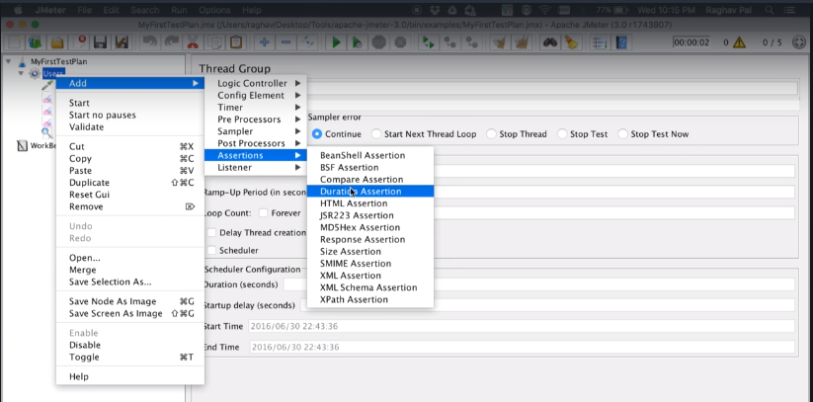

Enter the duration in milliseconds 1500 (1.5 sec). means the any response which takes more than 1500 milli seconds will be a failure.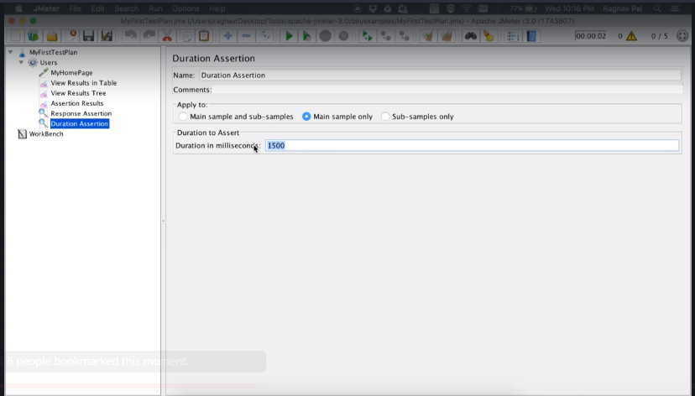

Run the test.the assertion results is below.all the responses take more than 1500 ms

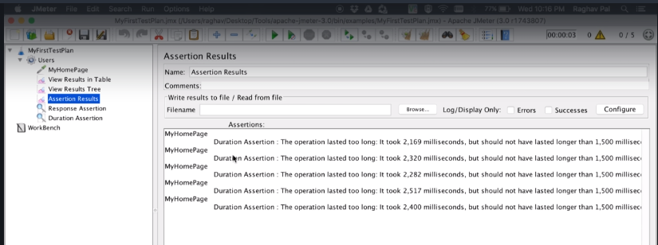

The results is showing as failure.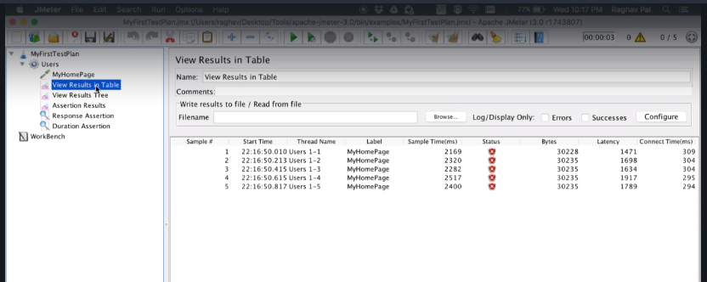

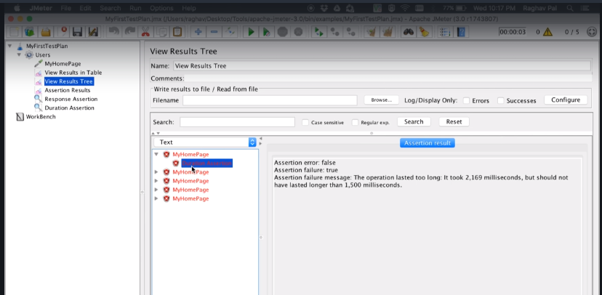

Change the duration 2200 based on the error message from the above screen.

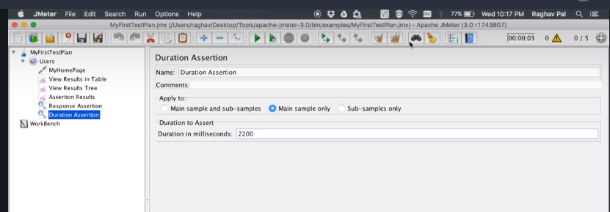

And run the test again.

The results are as below with test results pass.

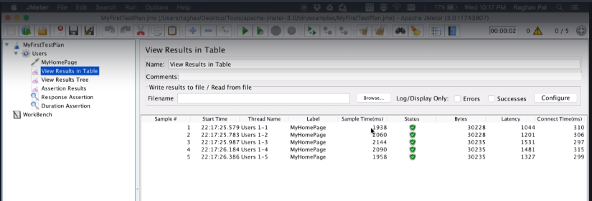

Size assertion

Threadgroup->add-> Assertion->size assertion

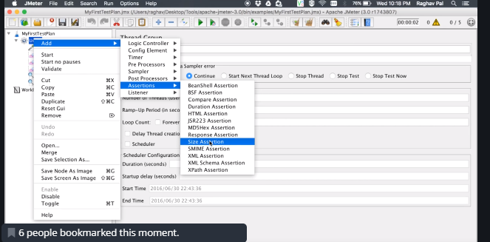

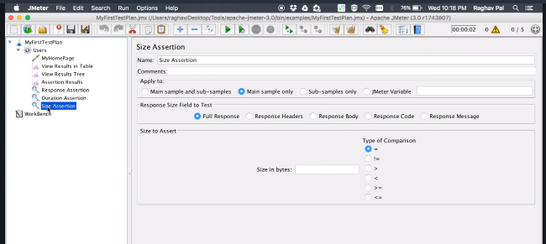

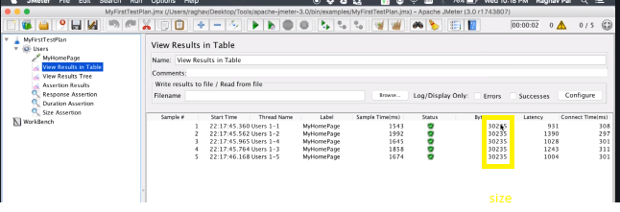

Provide the size and condition

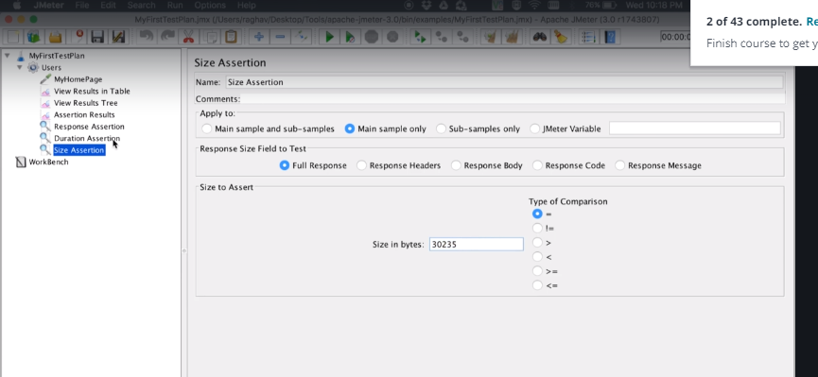

Run the test again and check the results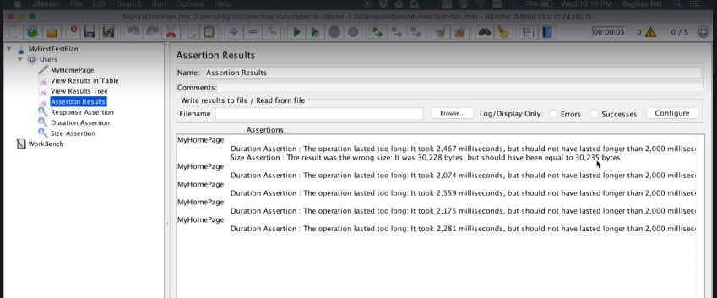

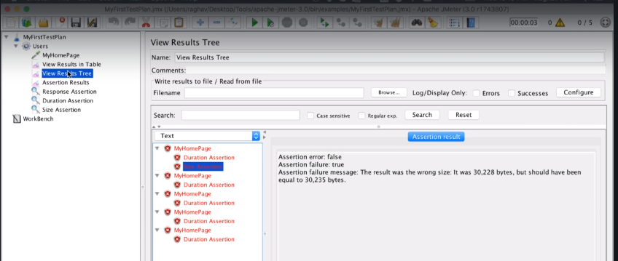

Increase the duration for removing the duration errors

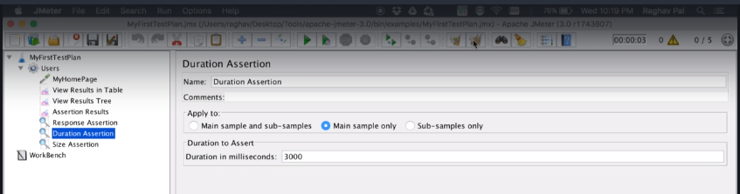

Again, run the test the result is below

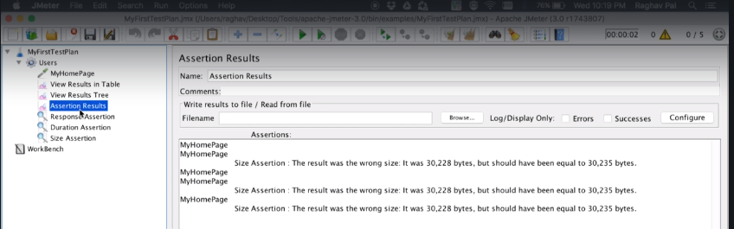

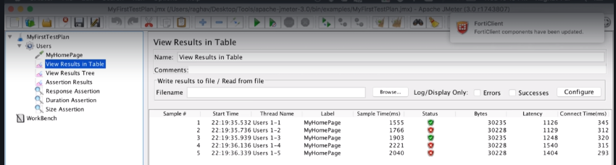

HTML assertion

thread group-> add-> Assertions-> Html assertion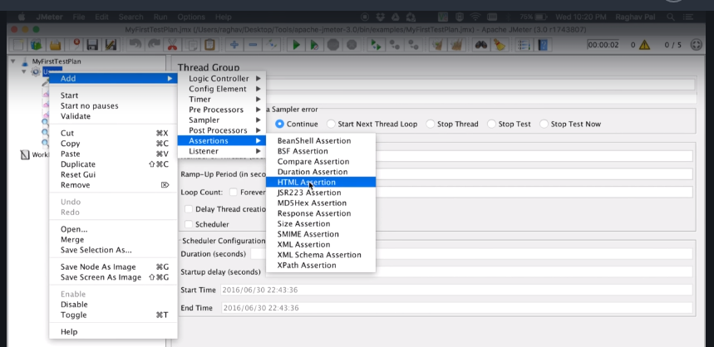

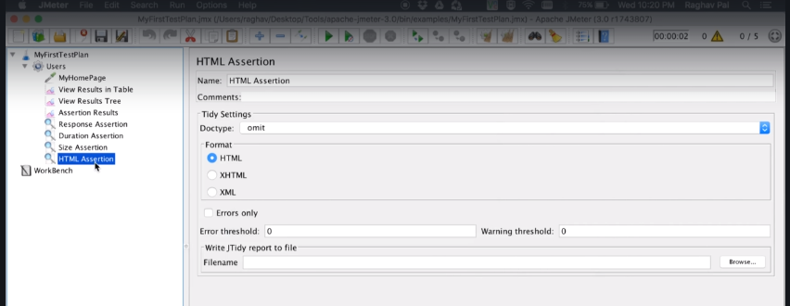

Run the test before providing the threshold errors and warnings in html assertion. The results is below

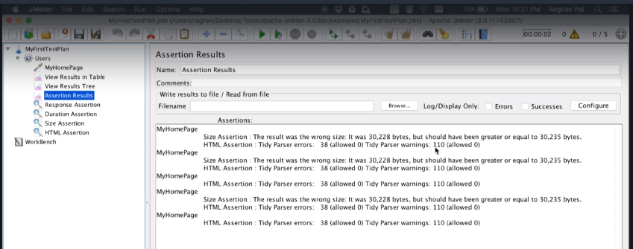

Provide the threshold errors and warnings and run the test again .

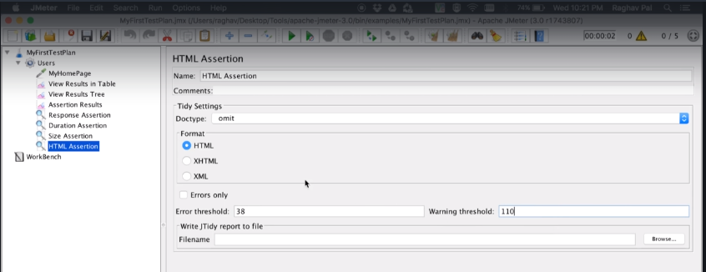

The results are below

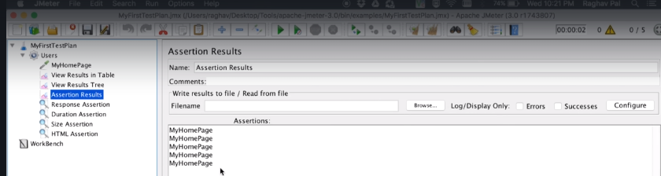

To get the reports for the test click on browse and select the file and check the Errors only checkbox.

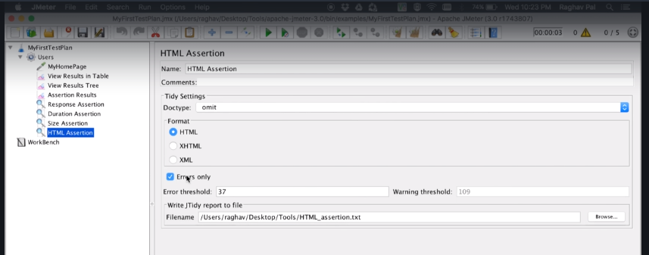

Run the test again and see the results and check the file for error

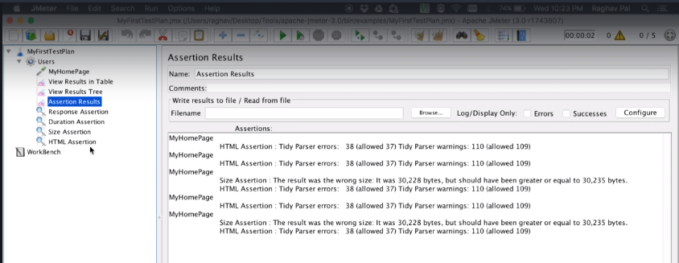

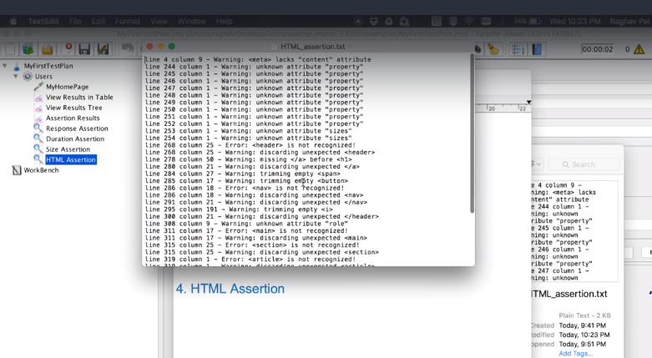

Xml assertion

thread group-> add-> Assertions-> Xml assertion

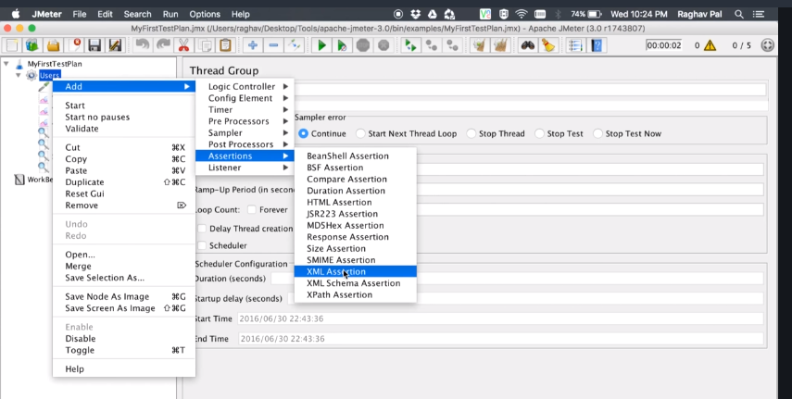

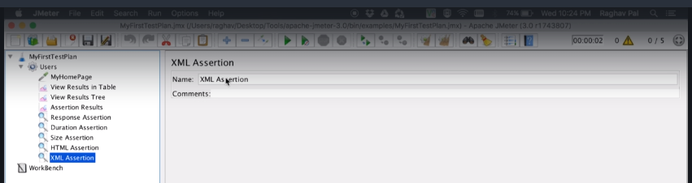

Run the test

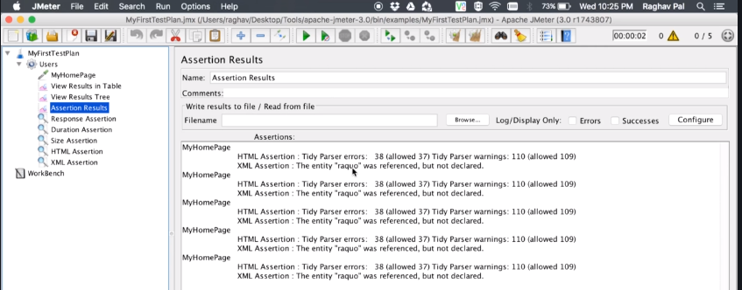

Xpath assertion This is used for api testing.

thread group-> add-> Assertions-> Xpath assertion

